Greg Heitman

Dr. Pulimood

CSC 415-01

7 March, 2016

Assignment 3 - Open Source Software: Proposal and Specifications

For this individual project, I will be choosing Option 1, where I will explore an open source project on *github.com* and make a significant contribution to its functionality. The project that I have selected is called Adopt-a-Hydrant, an open source project developed by Code For America. The project’s current functionality is a web-based application that displays a map, imported from Google Maps, of Boston, Massachusetts. This map contains the stored location of hundreds of fire hydrants throughout the city; these individual hydrants can be “adopted’ by users, who can essentially hold themselves responsible for maintaining them or shoveling them out during a snowstorm, in the event that sanitation workers cannot service them fast enough. For this web-based application, I will be developing using Ruby on Rails. The algorithm that I intend to implement will attempt to solve an issue posed on this project’s GitHub repository. In order to give the application greater social and interactive function, I aim to include a way for users to update information about hydrants that they might come across that haven’t been addressed, and allow these users to send a notification to the owner of that hydrant about the problems that need to be addressed. There should also be an option for a user to request ownership of a hydrant if they would like to take care of it themselves, notifying the current owner of this request. This project is innovative in two ways: it brings greater awareness to its users about their surrounding city streets and neighborhoods, and it lightens the workload of the public sanitation department by keeping an extra set of feet “on the ground” and allowing users to help the city in the event of a dangerous snowstorm. Some new concepts that I hope to learn are how to code using Ruby on Rails, as well as to learn how to create a message transfer system in Ruby to handle updates and notifications between users.

Use Case and Requirements Diagrams:

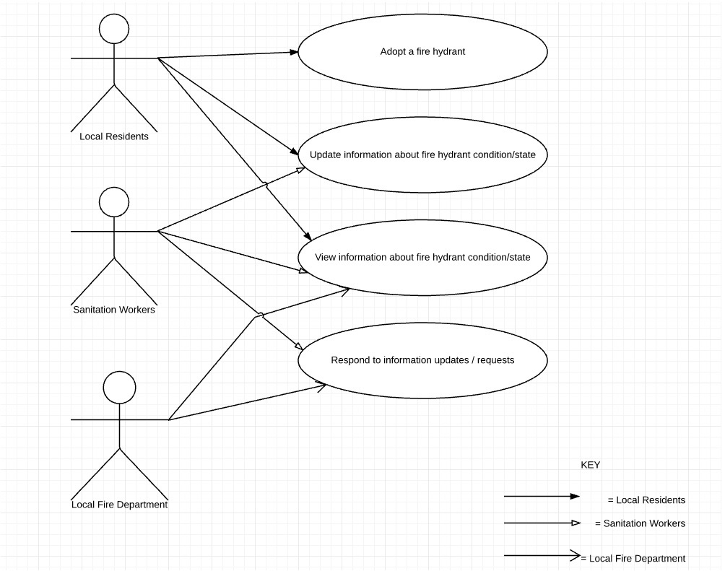

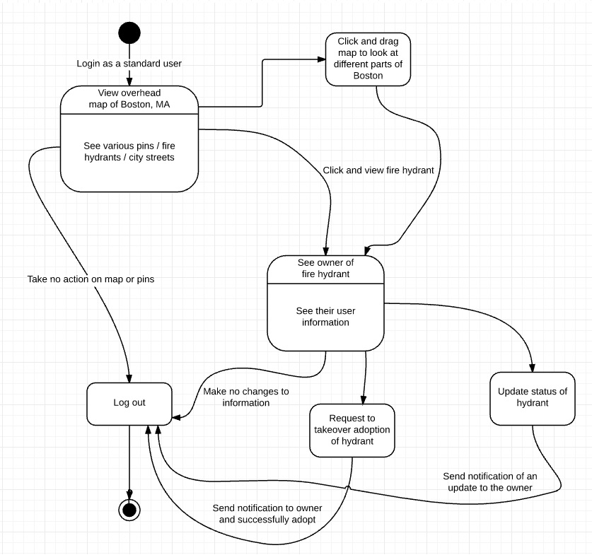

Open Source Licenses:

There are many open source licenses used to protect the ownership and rights to open source code. The MIT license is very broad, and allows users free and full access to all of a project’s source code so long as they allow these same rights to any future developers and users of the source code. The GNU General Public License is similar to the MIT license in terms of allowing users the freedom to develop code, but it puts more of an emphasis on protecting individual rights. GNU GPL developers protect the rights of users by both asserting copyright on the software that they use and offering the license giving legal permission to copy, distribute, or modify the software. A third type of open source license is the Apache License, which is similar to the others in terms of giving developers and users full access and rights to distribution or modification of code. This license goes into the most detail about license usage, contributions, trademark rights, and liability terms. For the purpose of my project, I feel it is best that I use the MIT license; it is the simplest and most practical for my purpose of modifying an existing open source project, and I don’t need to worry too much about licensing as I am not planning to redistribute my work.

Name of GitHub repository: *gregheitman/Adopt-A-Hydrant-Project*

Link to wiki page: <https://github.com/gregheitman/Adopt-A-Hydrant-Project/wiki>